Name: ________________________________________________________ Period: ____________ Teacher: Macedo

Week 3 ~Distance Learning ~ April 20th – April 24th
Assignment 3.1 – Carbon Footprint

A carbon footprint is the amount of greenhouse gases – primarily carbon dioxide – released into the atmosphere by a particular human activity. A carbon footprint can be the measured by the actions of an individual, a family, an event, an organization, or even an entire nation. It is usually measured in tons of CO₂ emitted per year.

An ecological footprint is the impact of human activities measured in terms of the amount of biologically productive land and water required to produce the goods consumed and absorb the waste generated by a person or country. More simply, it is the amount of the environment necessary to produce the goods and services necessary to support a particular lifestyle.

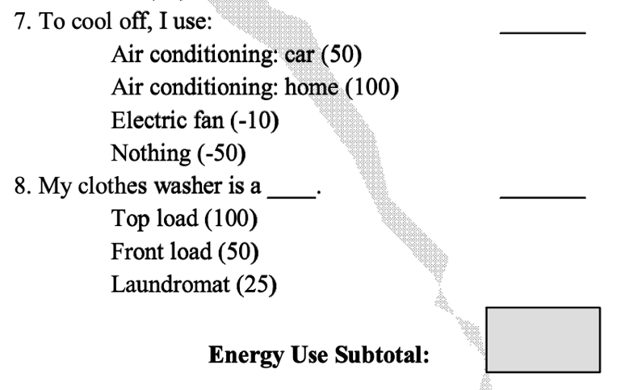
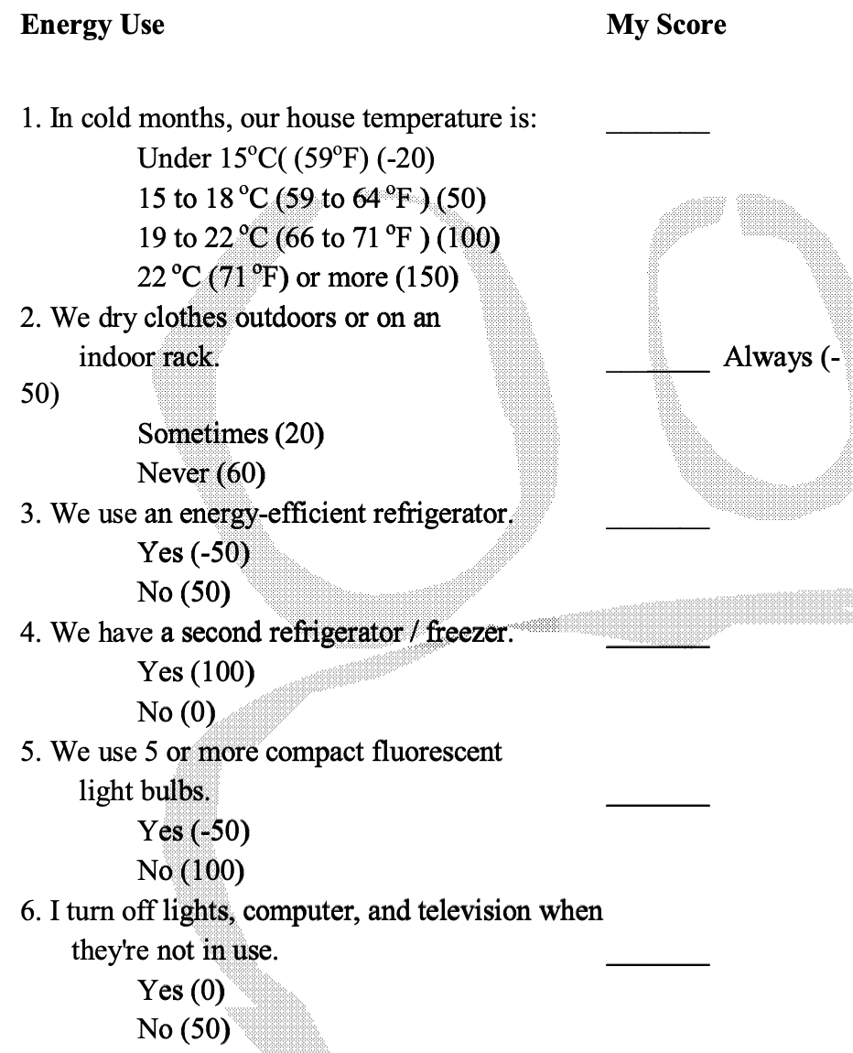
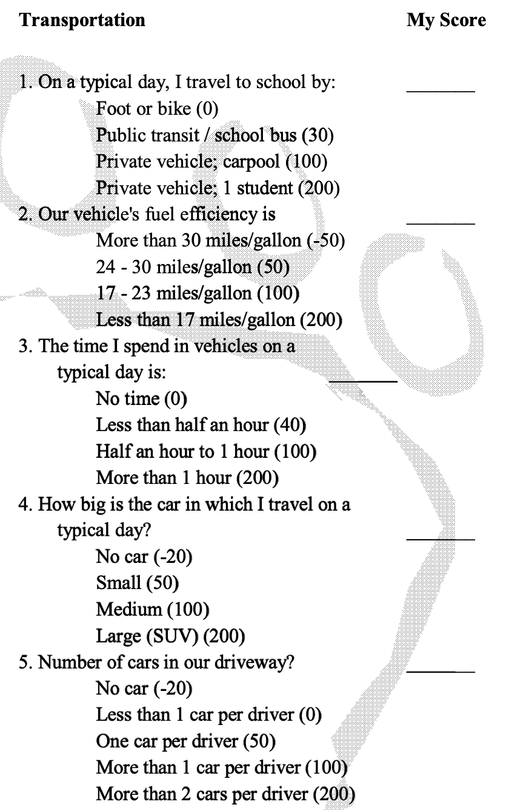
Complete the following survey to determine your carbon footprint/ecological footprint.

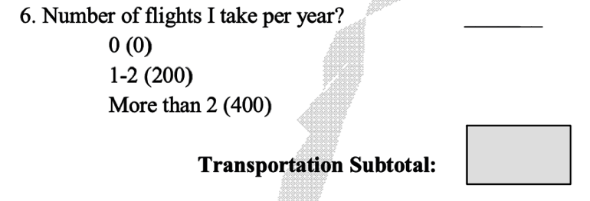






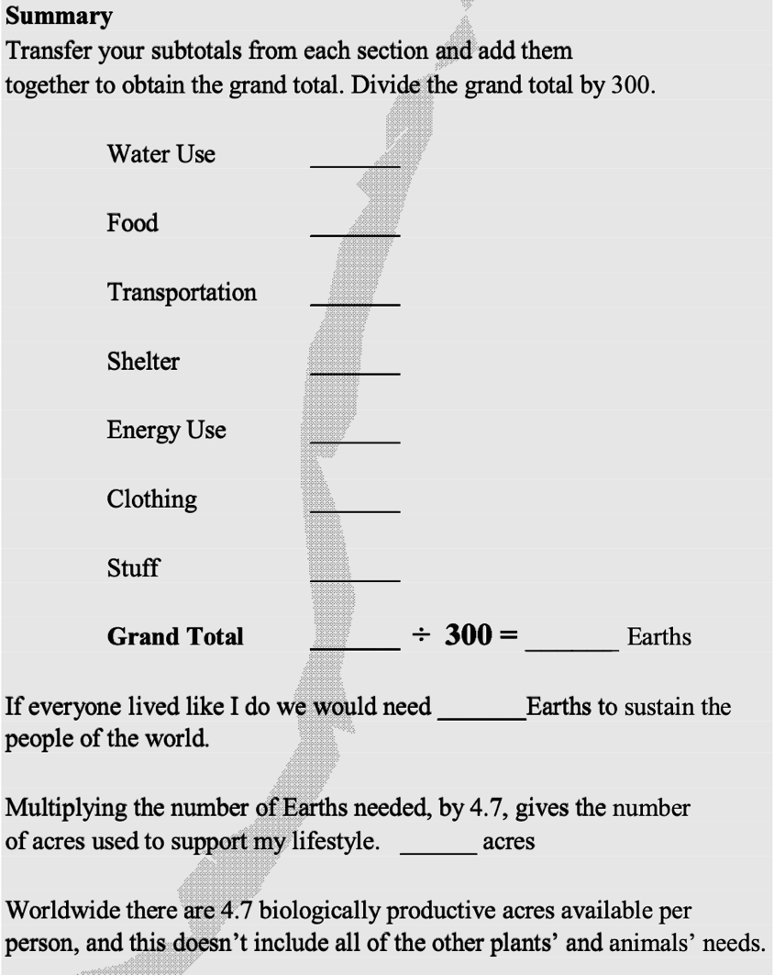


Answer the following questions based on your results -
- What was your ecological footprint according to the model in terms of the number of Earth’s necessary to sustain your lifestyle? Did this surprise you? Why or why not?

- Brainstorm 2-3 changes you could make to your lifestyle to reduce your footprint.

Assignment 3.2 – Solutions to Climate Change

Instructions
- The next 3 pages have information on different sectors that cause climate change and one possible solution.
- For each Sector:
  - Use the Sector Summary to answer the questions in column two (C2).
  - Read the Solution Summary and then answer the questions in column three (C3).
(C1) Sector | (C2) Sector Summary Questions | (C3) Solutions in this Sector
Electricity | - How do we use fossil fuels to create electricity?  - One of the solutions is says is to shift production—what does this mean? | - What solution does this describe?  - What does this mean?  - How does this solution reduce CO₂ (or other greenhouse gas) emissions?
Food, Agriculture, and Land Use | - How can addressing food waste and diets help reduce emissions?  - In what ways does agriculture produce greenhouse gases? (look under “shift agriculture practices”) | - What solution does this describe?  - What does this mean?  - How does this solution reduce CO₂ (or other greenhouse gas) emissions?
Transportation | - What are the 3 reasons we use liquid hydrocarbons (gasoline and diesel) for to power transportation?  - What does “Shift to Alternatives” mean? | - What solution does this describe?  - What does this mean?  - How does this solution reduce CO₂ (or other greenhouse gas) emissions?
Sector: Electricity
Summary: Electricity is particles in motion—a flow of electrons from one place to another that keeps air conditioners cooling, heaters heating, lights illuminating, computers computing, and all manner of motors humming. For much of the world, electricity powers the realities of daily life, yet 840 million people still lack access to electricity.
Since the emergence of electrical systems in the late 1800s, society has created most of its electricity by using fossil fuels. The process? Burn coal, oil, or natural gas. Heat water to create steam. Steam turns a turbine. Turbine rotates a generator, to get electrons moving. The locked-up energy of long-buried plants and animals is transmuted into electricity, as carbon dioxide spills into the atmosphere as a byproduct. Today, electricity production gives rise to 25% of heat-trapping emissions globally.
How can we generate electricity for the whole world without burning fossil fuels? How do the means of transmitting, storing, and using electricity need to evolve? These questions are critical for addressing emissions, especially given the current push to “electrify everything,” from cars to home heating, needing clean power on which to run. A mosaic of solutions is required, centered around electricity efficiency, production, and a more robust electrical system.
- Enhance Efficiency. Electricity efficiency solutions include technologies and practices that reduce demand for electricity generation, literally lightening the load. The two biggest end-users of electricity are buildings and industry, in roughly equal measure. While a home or factory may be the location of efficiency measures, these emissions get counted at the power plant where they are created or avoided, as part of the electricity sector. (See further exploration of buildings and industry below.)
- Shift Production. Production of electricity must move away from fossil fuels, as quickly as possible. A spectrum of solutions can help, from small-scale/distributed to large-scale/centralized. Some solutions harvest photons from the sun. Others tap nature’s generous kinetic energy—the movement of wind and water. Still others use an alternate source of heat, such as geothermal or nuclear, for the same basic steam-turbine process.
- Improve the System. To enable the transition to renewable electricity production and use, the broader electricity system also needs to evolve and upgrade. Flexible grids for transmission and effective energy storage make it possible to better balance electricity supply with demand.
As we look forward, an electricity transformation is undeniably possible. Already, economics favor wind and sun over fossil fuels in many places. A shift away from coal-powered electricity is underway in the United States, the United Kingdom, and much of Europe, albeit not fast or widespread enough. The speed of transformation is the issue at hand. We must curtail and supplant 19th and 20th-century forms of production more rapidly—including the large pipeline of proposed new coal plants—while ensuring that the future of clean electricity is equitable and empowering for all.

Solution: Concentrated Solar Power
Concentrated solar power (CSP), also known as solar thermal electricity, has been around since the 1980s. Instead of converting sunlight directly into electricity like photovoltaics (PV) do, it relies on the core technology of fossil-fuel generation: steam turbines. The difference is that rather than using coal or natural gas, CSP uses solar radiation as its primary fuel—free and clear of carbon.
Mirrors, the essential component of any CSP plant, are curved or angled in specific ways to concentrate incoming solar rays to heat a fluid, produce steam, and turn turbines. Because CSP relies on immense amounts of direct sunshine, it is best suited to hot, dry regions where skies are clear.
A critical advantage of CSP is energy storage. Unlike PV panels and wind turbines, CSP makes heat before it makes electricity, and heat is easier to store. When equipped with molten salt tanks for heat storage, CSP plants can continue to produce electricity well after the sun goes down.
As of 2014, CSP was limited to just 4 gigawatts worldwide. As the technology becomes more effective and less expensive, the central benefit of reliability will hasten its growth.
Sector: Food, Agriculture and Land Use
Summary: Human activity has transformed a significant fraction of the planet’s land, especially for growing food and harvesting forests. Land is the common ground of shelter, sustenance, feed for animals, fiber, timber, and some sources of energy, and the source of livelihood for billions of people. Our pursuit of those ends often disrupts or displaces ecosystems, and the twin forces of a growing population and rising consumption mean the challenge of stewarding land in sustainable ways will only intensify. Today, agriculture and forestry activities generate 24% of greenhouse gas emissions worldwide.
How can we reduce the pressures on ecosystems and land, while meeting the growing demands for food and fiber worldwide? How can we do what we do on land better, tending it in ways that decrease emissions from agriculture and forestry? The answers to these questions are critical for stemming greenhouse gases, sustaining the planet’s living systems, addressing food security, and protecting human health, all inextricably linked. Solutions in this sector are focused on waste and diets, ecosystem protection, and better agriculture practices.
- Address Waste and Diets. By shifting diets and addressing food waste, the global demand for food can significantly drop. Eating lower on the food chain and ensuring what’s grown gets eaten is a powerful combination that lowers farming inputs, land-clearing, and all associated emissions.
- Protect Ecosystems. When land and ecosystems are deliberately protected, activities that release carbon from vegetation and soil are stopped before they start. In addition, improving food production on existing farmland may reduce the pressure on other, nearby landscapes, thereby sparing them from clearing.
- Shift Agriculture Practices. Better agriculture practices can lower emissions from cropland and pastures, including methane generated by growing rice and raising ruminants, nitrous oxide emitted from manure and overusing fertilizers, and carbon dioxide released from disturbing soils.
Farming and forestry practices can also support the role of land in removing greenhouse gases from the atmosphere. Many solutions that stop land-based emissions also enhance carbon sinks (explored below). Solutions in this sector are significant for improving food security and agricultural resilience as well, particularly because many of them contribute to a more robust food system, better able to withstand climate impacts.

Solution: Plant-Rich Diet

Shifting to a diet rich in plants is a demand-side solution to global warming that runs counter to the meat-centric Western diet on the rise globally. That diet comes with a steep climate price tag: one-fifth of global emissions. If cattle were their own nation, they would be the world’s third-largest emitter of greenhouse gases.
Plant-rich diets reduce emissions and also tend to be healthier, leading to lower rates of chronic disease. According to a 2016 study, business-as-usual emissions could be reduced by as much as 70 percent through adopting a vegan diet and 63 percent for a vegetarian diet, which includes cheese, milk, and eggs. $1 trillion in annual health-care costs and lost productivity would be saved.
Bringing about dietary change is not simple because eating is profoundly personal and cultural, but promising strategies abound. Plant-based options must be available, visible, and enticing, including high-quality meat substitutes. Also critical: ending price-distorting government subsidies, such as those benefiting the U.S. livestock industry, so that the prices of animal protein more accurately reflect their true cost.
As Zen master Thich Nhat Hanh has said, making the transition to a plant-based diet may be the most effective way an individual can stop climate change.

Sector: Transportation

Summary: Getting people or things from point A to point B, and perhaps back again: in some ways, transportation is incredibly simple. Human beings would be stuck at the speed of walk, run, swim, or horse if it weren’t for planes, trains, automobiles, buses, bicycles, and boats. Mobility has played a critical and complex role in shaping society, and the demand for it is only growing.
Most of the energy driving mobility has, to date, been generated by burning liquid hydrocarbons, namely gasoline, diesel, and jet fuel. Why? Because of a formidable combination of energy density (the energy contained within a liter or gallon), abundance, and low cost. But account for what isn’t included in that price, and petroleum-powered mobility is expensive indeed. Particulate matter harms human health. Oil spills ruin land and water. And then there’s the cost to the climate system: Transportation is responsible for 14% of global greenhouse gas emissions.
How can we support the social good of mobility, but end its dependence on petroleum? In what ways do vehicles, infrastructure, and operations need to change, to eliminate transportation emissions? These are the questions society must answer if we want to keep moving—ourselves or other items—for reasons of necessity, pleasure, or commerce. Transportation solutions address alternatives, fuel efficiency, and electrification.
- Shift to Alternatives. Alternative modes of mobility reduce demand for fossil-fueled transportation or replace it altogether. With public and “pooled” transit, we can make the most of available seats. Compact cities, intentional infrastructure, and advanced communication technologies make it possible to walk, cycle, or simply stay put.
- Enhance Efficiency. Where combustion engines remain in use, vehicles can be made far more fuel-efficient through mechanical improvements, lightweighting, better design, and more artful operation.
- Electrify Vehicles. Electrification of vehicles completely replaces petroleum—and has even greater benefits when paired with renewable electricity generation. (If charged from coal-powered electricity, EVs can cause more harm than good.)
These transportation solutions have the potential to save money and preempt pollution, but the transformations required are substantial and the sector can be slow to move. Vehicles remain in use for many years. New transportation infrastructure is expensive and takes time to build. Clean fuels for airplanes remain distant. But many of the solutions can, if done intelligently, create more equitable mobility and livability in our cities and communities, without forfeiting the stability of our climate.

Solution: Bicycle Infrastructure

Bicycles are on the rise as cities attempt to untangle traffic and unclog skies, urban dwellers seek affordable transportation, and diseases of inactivity and billowing greenhouse gases become impossible to ignore. Infrastructure is essential for supporting safe, pleasant, and abundant bicycle use, and includes:
- Networks of well-lit, tree-lined bike lanes or paths—the more direct, level, and interconnected the better.
- Well-designed intersections, roundabouts, and points of access, where bicycles and cars meet.
- Access to public transport, secure bike parking, city bike-share programs, and workplace showers.
In the places where cycling thrives, programs and policies complement physical infrastructure. Educational initiatives target cyclists and motorists alike, for example, and stricter liability laws protect those on two wheels. Numbers from the world’s cycling capitals are compelling. In Denmark, 18 percent of local trips are done on two wheels, and in the Netherlands, 27 percent—with virtually zero emissions.
A virtuous cycle is clear: With more infrastructure come more riders. Perhaps counter intuitively, with more infrastructure and more riders, safety improves. And the more bicycles there are traversing a city, the more it reaps numerous returns on investment, including the health benefits of cleaner air and greater physical activity.

Assignment 3.3: Lockdown Impact on Carbon Footprints - Article Analysis
Instructions:
- Read the article provided (It starts on the bottom of this page) about how lockdown has impacted the carbon footprint we have. The article is about India where the Himalayan mountain range cannot be seen due to sever pollution
- As your read, please answer the following questions in complete sentences. Type your answers in directly below the questions. When you are finished, upload the document to Turnitin.com.
Questions to answer:
- What major change has happened to the air over the last month in this location because of lockdown?
- Describe the positive and negative impacts lockdown has had on the daily lives of people in this area.
  - Positive impacts:

  - Negative impacts:
- Since smog is created by combustion of carbon-based fuels, based on what you read, what factors are creating smog in this area?

- When lockdown is lifted in a few months, give at least 2 ideas on how you would suggest this area reduce their air pollution (their carbon footprint).

In India, life under coronavirus brings blue skies and clean air.
This story was adapted from an article by Joanna Slater writer for washingtonpost.com written April 11, 2020; the Washington Post is a well-recognized daily newspaper written in Washington D.C.
NEW DELHI — Inside the world’s largest lockdown, there are no flights, no passenger trains, no taxis and few functioning industries. But one thing is remarkably abundant: cleaner air. India is engaged in a desperate bid to “flatten the curve” of coronavirus cases before they overwhelm the creaky health system in this nation of more than 1.3 billion people.
In the meantime, the three-week lockdown is flattening something else — India’s notorious air pollution. The speed of the change has surprised even experts, who say it is proof that dramatic improvements in air quality can be achieved, albeit at an enormous human and economic cost.
Days after the lockdown began on March 25, the level of particle pollution considered most harmful to human health fell by nearly 60 percent in New Delhi, India’s capital, according to an analysis by experts at the nonprofit Center for Science and Environment. Similar drops have occurred in other major Indian cities.
In normal times, Delhi is the world’s most polluted megalopolis. For much of the winter, air quality readings remained at levels that in the United States are considered unhealthy or worse. Last November, the city experienced its longest spell of hazardous air since such record keeping began.
These days, Delhiites are stuck at home except when picking up essential goods. But above them are blue skies, the moon and the stars, seen without the usual barrier of smog. The sight is so striking that “I feel like complimenting the sky for its beauty,” said Sameer Dhanda, 26, an architect.
In other parts of India, the Himalayan mountain range is visible from a distance for the first time in years. Waterways choked by industrial pollution, such as Delhi’s Yamuna River — full of gray foam just months ago — are flowing unimpeded.
The current reduction in pollution has come at a steep price. Much of the Indian economy has been idled, forcing vulnerable workers to travel hundreds of miles to their home villages on foot. Millions could be plunged into poverty or hunger if the lockdown continues beyond its initial three-week period.
But experts say that there are still lessons to be gleaned, including a chance to imagine a different future. The decrease in pollution is a “proof of concept” that demonstrates clean air “is doable,” said Ajay Mathur, a former Indian climate negotiator and a member of Prime Minister Narendra Modi’s council on climate change. “The linkage between personal behavior and what I will breathe is far clearer now than it has been in the past.”
The first step for any government is to ensure that “the vast number of Indians have sustainable livelihoods,” Mathur added. Nevertheless, he hopes that policy changes — such as phasing out dirty industrial fuels and accelerating the shift to environmentally friendly vehicles — will get a boost in the post-pandemic world.
Mathur often suffers from a raspy voice and persistent cough that doctors have told him is related to Delhi’s bad air. In the past two weeks, he said, such symptoms have vanished.
One terrible irony of the current crisis is that a pandemic that makes it difficult for some to breathe has, by curbing pollution, eased respiratory troubles for others. Pulmonologists in Delhi say many of their regular patients are breathing easier and reducing their use of inhalers. For them, this period is a kind of boon, said Arvind Kumar, a chest surgeon and trustee of the Lung Care Foundation.
India’s long-running battle with pollution may have rendered it particularly vulnerable to the novel coronavirus. Researchers at Harvard recently found that places with long-term exposure to higher levels of fine particle pollution — known as PM2.5 — were associated with higher rates of death caused by covid-19. Such particles can lodge deep in the lungs and have been linked to high blood pressure, heart disease, respiratory infections and even cancer. So far, about 200 people in India have died of covid-19, with more than 6,500 cases of the illness confirmed.
Anumita Roy Chowdhury, an air pollution expert at Delhi’s Center for Science and Environment, described India’s improved air quality as “a very big unintended experiment unfolding in front of us.” The lockdown demonstrates “the scale at which change is needed,” she said, but also shows people “what it means to breathe clean air.”
In a huge swath of northern India, the air quality normally varies from poor to apocalyptic, depending on the time of year, with a brief respite during the annual monsoon. The worst period begins when temperatures drop in October, trapping near ground level a mix of industrial emissions, road dust, vehicular exhaust and ash from burned crop stubble. Pollution begins to ease in February.
Jyoti Pande Lavakare, an author and anti-pollution activist in Delhi, said she doesn’t remember seeing skies of this type of blue at this time of year in at least a decade. In recent days, she began doing her morning exercises outside and found herself lying on her back on her yoga mat, just gazing at the sky.
“After we battle the current pandemic, we need to revisit how we treat the invisible killer of air pollution,” Lavakare said. The World Health Organization estimates that polluted air kills 7 million people annually.
For now, Delhi residents are treasuring a rare upside of a time marked by fear and worry. Priyanki Choudhury, a 29-year-old account manager, said she has not experienced anything like this — clear blue skies in the day and stars at night — since she was a teenager. Choudhury was not sure whether the lockdown would succeed in stemming the spread of covid-19. But, for the environment, she said, it is clearly a “time to heal.”

